The Islamia University of Bahawalpur
Department of Information Technology



SOFTWARE REQUIREMENTS
SPECIFICATION
(SRS DOCUMENT)

For

E commerce Shoe Store

By
Gul Zainab
F22BINFT1E02042
Fall 2022 – 2026

Supervisor
Dr. Musarat Karim

Bachelor of Science in Information Technology

Table Of Content Introduction…………………………………………………………………………………………………4
  - Purpose………………………………………………………………………………………4
  - Scope…………………………………………………………………………………………4
  - Definitions……………………………………………………………………………4
  - Technologies Used…………………………………………………………………………………5
Overall Description………………………………………………………………………………5
2.1 Product Perspective…………………………………………………………………………5
2.2 User Classes………………………………………………………………………………5
2.3 Constraints…………………………………………………………………………………6
2.5 Assumptions…………………………………………………………………………6
Functional Requirements………………………………………………………………………6
3.1 User Module……………………………………………………………………………6
3.2 Product Module……………………………………………………………………7
3.3 Cart Module………………………………………………………………………7
3.4 Order Module…………………………………………………………………8
3.5 Payment Module………………………………………………………………8
3.6 Admin Module……………………………………………………………8
Non Functional Requirements…………………………………..……………9
4.1 Performance Requirements…………………………………………………9
4.2 Security Requirements………………………………………………………………9
4.3 Usability Requirements…………………………………………………………9
4.4 Reliability Requirements…………………………………………………………9
4.5 Compatibility Requirements……………………………………………………………10
System Models………………………………………………………………………………………10
5.1 Use Case Diagram…………………………………………………………………………10
Database Requirements………………………………………………………………………10
6.1 Tables/Collections…………………………………………………………………11
Future Enhancements……………………………………………………………………………11
Conclusion…………………………………………………………………………………………11

1. Introduction

1.1 Purpose

The purpose of this SRS is to describe all the functional and non-functional requirements for the “E-Commerce Shoe Store” project. This document will help developers, designers, and stakeholders understand the system requirements clearly and ensure smooth development.

1.2 Scope

The E-Commerce Shoe Store is a web-based platform where users can browse, search, and purchase shoes online.
The system will allow:
• Users to view shoe categories (men, women, kids, sports, casual, etc.)
• Users to register, log in, add items to the cart, place orders, and make online payments.
• Admin to manage products, categories, orders, and customers.

1.3 Definitions
• User/Customer: A person who visits the website and buys products.
• Admin: Person who manages the store back-end.
• Product: Shoe item available for sale.
• Cart: Temporary storage of selected products before checkout.

1.4 Technologies Used
• Front-end: HTML, CSS, JavaScript, React
• Back-end: Node.js or Firebase
• Database: MongoDB
• Tools: GitHub, Visual Studio Code

2. Overall Description

2.1 Product Perspective

The system is an independent web application. It consists of:
• User Interface (UI)
• Admin Dashboard
• Database for storing products, users, and orders.

2.2 User Classes
1. Guest User
• Browse products
• Search shoes
• View product details
2. Registered User
• All guest functions
• Add to cart
• Checkout and order
• Track order status
• Manage profile
3. Admin
• Add/edit/delete products
• Manage categories
• Manage orders
• View customer details

2.3 Constraints
• Requires stable internet connection
• Payment gateway integration must follow security standards
• Limited to web browsers (Chrome, Firefox, Safari)

2.4 Assumptions
• Users know how to browse and use e-commerce sites
• Admin manages inventory regularly

3. Functional Requirements

3.1 User Module

FR-1: User Registration
• The system shall allow users to register using email and password.

FR-2: User Login
• The system shall authenticate users before granting access to personal features.

3.2 Product Module

FR-3: View Products
• Users can view all shoes listed with details (name, price, sizes, brand, images).

FR-4: Product Filters
• Users can filter shoes by category, size, color, and price.

FR-5: Search
• Users can search for shoes using keywords.

3.3 Cart Module

FR-6: Add to Cart
• Registered users can add products to the cart.

FR-7: Update Cart
• Users can update quantity or remove items.

3.4 Order Module

FR-8: Checkout
• The system shall allow users to place orders by providing address and payment details.

FR-9: Order Confirmation
• The system must generate a confirmation message and order ID.

3.5 Payment Module

FR-10: Online Payment
• Integration with payment gateway for card or wallet payments.

3.6 Admin Module

FR-11: Manage Products
• Admin can add, edit, or delete products.

FR-12: Manage Orders
• Admin can view and update order statuses (Pending, Shipped, Delivered).

FR-13: Manage Customers
• Admin can view customer profiles and purchase history.

4. Non-Functional Requirements

4.1 Performance Requirements
• Pages must load within 3 seconds.
• The system must support at least 1000 users simultaneously.

4.2 Security Requirements
• User passwords must be encrypted.
• Payment information must be securely processed.
• Admin access must require authentication.

4.3 Usability Requirements
• UI should be simple, modern, and mobile-responsive.
• Product images must be high quality.

4.4 Reliability Requirements
• The system should have 99% uptime.
• Daily backup of database records.

4.5 Compatibility Requirements
• Supports all major browsers.
• Compatible with mobile, tablet, and desktop.

5. System Models

5.1 Use Case Diagram

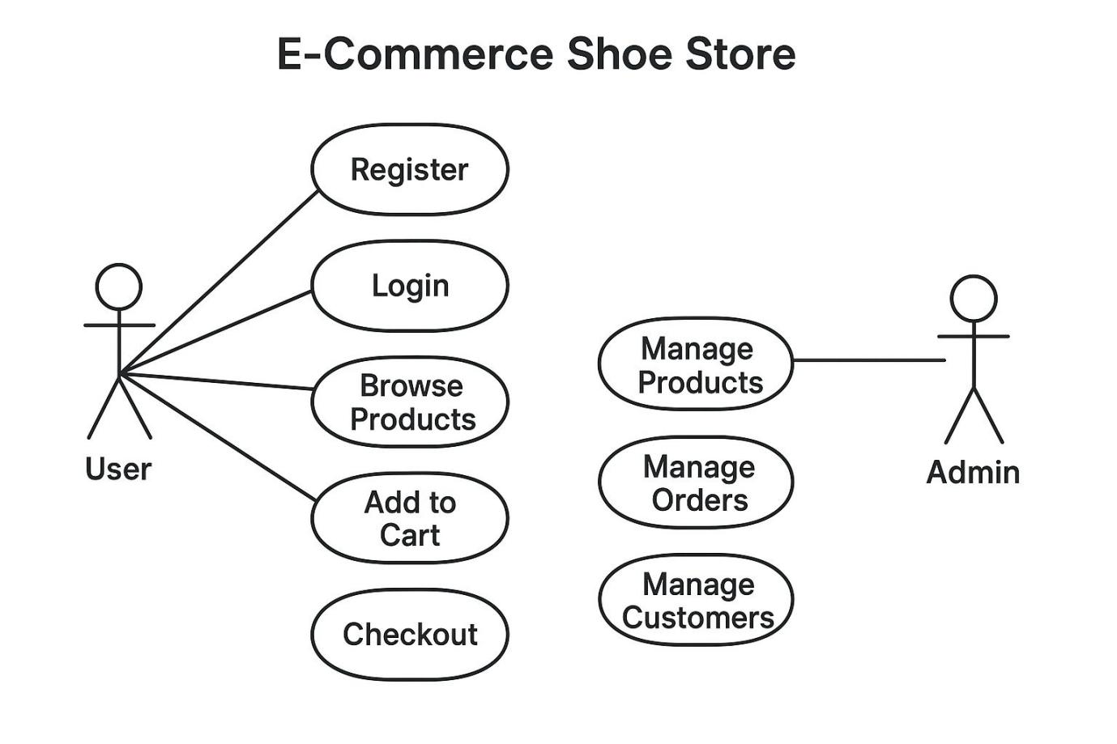

6. Database Requirements

6.1 Tables / Collections
• Users (UserID, Name, Email, Password)
• Products (Product-ID, Name, Price, Size, Category, Image, Stock)
• Categories (CategoryID, CategoryName)
• Orders (Order-ID, User-ID, Product List, Total Amount, Status)
• Cart (User-ID, Product ID, Quantity)

7. Future Enhancements
• Wish-list feature
• Shoe customization tool
• AI-based size recommendation
• Review and rating system

8. Conclusion

This SRS clearly defines goals, requirements, and specifications for the E-Commerce Shoe Store. It will help developers create a complete, user-friendly, and efficient online shoe selling platform.

